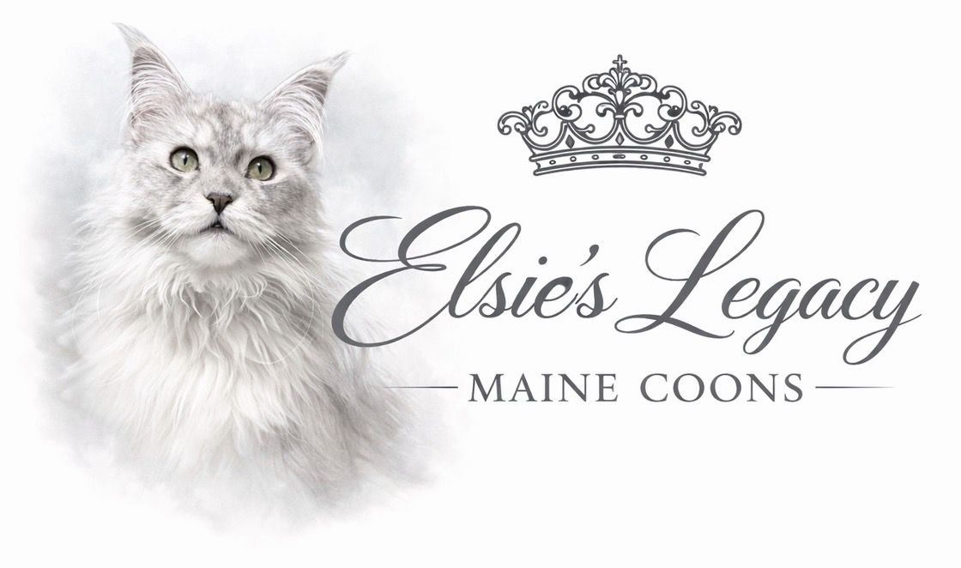
Elsie’s Legacy Maine Coon Cattery
Companion Kitten Purchase Agreement

1. Purchase Terms

1.1 Purchase Price
The total purchase price of the kitten is $__________ USD, unless otherwise agreed to in writing by the Breeder. The purchase price includes the kitten described in this Agreement and any items specifically listed as included by the Breeder.

1.2 Reservation Deposit
A non-refundable reservation deposit of One Thousand Five Hundred Dollars ($1,500.00 USD) is required to reserve a kitten. A kitten shall not be considered reserved until the deposit has been received and accepted by the Breeder. The reservation deposit shall be applied toward the total purchase price of the kitten.

1.3 Accepted Forms of Payment
Reservation deposits may be paid by Zelle, cash, or another payment method approved by the Breeder.
The remaining balance of the purchase price shall be paid in cash at the time of pickup, unless otherwise approved in writing by the Breeder.

1.4 Buyer Cancellation
If the Buyer chooses not to complete the purchase for any reason, the reservation deposit shall be forfeited and retained by the Breeder as compensation for reserving the kitten and removing it from availability.

1.5 Breeder Cancellation
If the Breeder determines that the kitten should not be placed due to illness, injury, temperament, or any other condition affecting the kitten’s health or welfare before transfer of ownership, the Buyer shall receive a full refund of all monies paid unless both parties agree to transfer the deposit to another available or future kitten.
The Breeder reserves the sole right to determine whether a kitten is suitable for placement.

1.6 Right to Refuse Sale
The Breeder reserves the right to refuse or cancel the sale of any kitten at any time if the Breeder believes placement is not in the best interest of the kitten.
If the Breeder cancels the sale for reasons unrelated to the Buyer’s actions or failure to comply with this Agreement, all monies paid by the Buyer shall be refunded in full.

1.7 Pickup & Boarding
The Buyer agrees to take possession of the kitten on the mutually agreed-upon pickup date.
If the Buyer requests that the kitten remain with the Breeder beyond the agreed pickup date, the request must be approved in writing by the Breeder.
If approved, a boarding fee of $50.00 per calendar day may be charged beginning on the fourth (4th) day after the scheduled pickup date to cover continued care, food, housing, and supervision.
Failure to complete pickup within the approved timeframe may result in cancellation of the sale. In such event, the Breeder may retain the reservation deposit and place the kitten in another approved home.

2. Breeder Responsibilities

2.1 Health Prior to Placement
The Breeder certifies that the kitten is in good health, to the best of the Breeder’s knowledge, at the time of transfer. Prior to leaving the Breeder’s care, the kitten will have received age-appropriate veterinary care and will have been examined by a licensed veterinarian.

2.2 Vaccinations & Preventative Care
Before placement, the kitten will have received age-appropriate vaccinations and preventative care as determined appropriate by the Breeder and attending veterinarian. The Buyer understands that additional vaccinations, parasite prevention, and routine veterinary care will be required after the kitten leaves the Breeder’s care and are the responsibility of the Buyer.

2.3 Health Testing
Elsie’s Legacy Maine Coon Cattery is committed to ethical preservation breeding and prioritizes the health of every kitten produced.
All breeding cats are comprehensively health tested prior to breeding. Health testing includes:
- DNA testing through Optimal Selection for more than 40 known feline genetic mutations, including but not limited to Hypertrophic Cardiomyopathy (HCM), Spinal Muscular Atrophy (SMA), Polycystic Kidney Disease (PKD), and Pyruvate Kinase Deficiency (PKDef).
- Echocardiograms performed by qualified veterinary specialists to evaluate heart health.
- Hip evaluations performed by qualified veterinary specialists to screen for hip dysplasia.
While no breeder can guarantee a kitten will never develop a medical condition, these health screenings significantly reduce the risk of inherited disease and demonstrate the Breeder’s commitment to producing healthy, well-bred Maine Coons.

2.4 Registration & Pedigree
The kitten is registered, or eligible for registration, with the Cat Fanciers’ Association (CFA). Registration paperwork will be provided to the Buyer after all terms of this Agreement have been satisfied.
The Breeder guarantees that the kitten is a purebred Maine Coon with an accurate pedigree.

2.5 What the Buyer Will Receive
At the time of pickup, the Buyer will receive the following, as applicable:
- CFA registration paperwork or registration information.
- A pedigree.
- Veterinary examination records.
- Vaccination records.
- Deworming records, if applicable.
- Feeding recommendations.
- Care instructions for transitioning the kitten into its new home.
- Lifetime breeder support.

2.6 Transfer of Ownership
Ownership of the kitten shall not transfer to the Buyer until:
- Full payment has been received by the Breeder.
- Both parties have signed this Agreement.
- The kitten has been released by the Breeder.
Until all of these conditions have been met, the kitten shall remain the sole property of the Breeder.

3. Health Guarantee

3.1 Health at the Time of Placement
The Breeder guarantees that, to the best of the Breeder’s knowledge, the kitten is healthy at the time of transfer. Prior to placement, the kitten will have been examined by a licensed veterinarian and determined to be free of any known life-threatening illness or congenital defect that would prevent it from living a normal companion life.
Because relocating to a new home can be stressful, the Buyer understands that mild symptoms such as temporary decreased appetite, loose stool, sneezing, or hiding may occur during the transition period and do not necessarily indicate illness or a breach of this Agreement.

3.2 Initial Veterinary Examination
The Buyer agrees to have the kitten examined by a licensed veterinarian within seventy-two (72) hours of taking possession.
If the examining veterinarian determines that the kitten has a serious congenital or pre-existing medical condition that existed prior to placement, the Buyer must notify the Breeder immediately and provide:
- A written veterinary report describing the diagnosis.
- Supporting medical records, test results, and treatment recommendations.
The Breeder reserves the right to request confirmation of the diagnosis by a second licensed veterinarian of the Breeder’s choosing before any remedy is provided.
Failure to have the kitten examined within seventy-two (72) hours may void this portion of the health guarantee unless otherwise approved by the Breeder.

3.3 Genetic Health Guarantee
The Breeder guarantees the kitten against death caused solely by a confirmed hereditary genetic disease until thirty-six (36) months of age.
If a licensed veterinarian determines that the kitten has died as the direct result of a hereditary genetic condition, and the Breeder receives sufficient veterinary documentation supporting the diagnosis, the Breeder will provide one (1) replacement companion kitten of comparable quality when available.
The replacement kitten shall not include transportation costs or additional services unless otherwise agreed upon in writing.

3.4 Conditions Not Covered
This health guarantee does not cover conditions resulting from, or related to:
- Accidents or trauma.
- Injury.
- Abuse or neglect.
- Failure to provide routine veterinary care.
- Exposure to infectious diseases after placement.
- Parasites acquired after placement.
- Improper nutrition or obesity.
- Environmental toxins.
- Reactions to medications or vaccinations.
- Stress associated with relocation.
- Any condition caused by circumstances outside the Breeder’s control.
The Buyer understands that no breeder can guarantee a kitten will never develop a medical condition during its lifetime.

3.5 Veterinary Expenses
The Buyer assumes full responsibility for all veterinary expenses incurred after the kitten leaves the Breeder’s care.
The Breeder shall not be responsible for reimbursement of veterinary costs, emergency treatment, diagnostic testing, medications, hospitalization, or other expenses unless otherwise agreed to in writing.

3.6 Limitation of Health Guarantee
This health guarantee applies only to the original Buyer named in this Agreement and is not transferable.
Any replacement kitten offered under this Agreement shall satisfy the Breeder’s obligations under the health guarantee.

4. Buyer’s Rights & Responsibilities

4.1 Lifetime Care
The Buyer agrees to provide the kitten with a safe, loving, and permanent home for the duration of its life. The Buyer shall provide appropriate nutrition, fresh water, shelter, enrichment, exercise, routine veterinary care, emergency medical treatment when necessary, and all other care reasonably required to maintain the cat’s health and well-being.
The Buyer acknowledges that adopting a kitten is a long-term commitment and accepts full responsibility for the cat throughout its lifetime.

4.2 Veterinary Care
The Buyer agrees to establish veterinary care promptly after bringing the kitten home and to maintain routine wellness examinations, vaccinations as recommended by their veterinarian, parasite prevention when appropriate, and prompt treatment of illness or injury.
Failure to seek appropriate veterinary care for a sick or injured cat may constitute a material breach of this Agreement.

4.3 Indoor-Only Requirement
The Buyer agrees that the cat shall live primarily as an indoor companion.
Outdoor access is permitted only when the cat is:
- Supervised while wearing a properly fitted harness and leash.
- Contained within a secure catio or other fully enclosed outdoor enclosure.
- Safely contained within a secure stroller, backpack, or travel carrier.
The cat shall never be permitted to roam freely outdoors unattended.

4.4 No Declawing
The Buyer agrees that the cat shall never be declawed, except when deemed medically necessary by a licensed veterinarian for the health of the cat.
The Buyer understands that declawing is an amputation procedure that removes part of each toe and may result in lifelong physical and behavioral complications.
Appropriate scratching posts, cat trees, nail trimming, and other humane alternatives should be provided throughout the cat’s lifetime.

4.5 Housing & Enrichment
The Buyer agrees to provide a clean, sanitary, and enriching environment, including appropriate scratching surfaces, climbing opportunities, toys, resting areas, and regular social interaction.
The cat shall not be continuously confined to a cage except during transportation, veterinary treatment, recovery from medical procedures, or other temporary circumstances necessary for the cat’s safety or health.

4.6 Identification
The Buyer agrees to make reasonable efforts to ensure the cat can be identified if lost, including maintaining current identification information on any microchip and using identification tags when appropriate.

4.7 Transfer of Ownership
The Buyer shall not sell, give away, trade, lease, surrender, abandon, or otherwise transfer ownership of the cat without the prior written consent of the Breeder.
If the Buyer is no longer able to care for the cat at any point during its lifetime, the Breeder shall be contacted before any attempt is made to rehome the cat.

4.8 Return to Breeder
If the Buyer is unable or unwilling to keep the cat for any reason, the cat shall be returned to the Breeder or rehomed only with the Breeder’s written approval.
Under no circumstances shall the cat be surrendered to:
- An animal shelter.
- A rescue organization.
- A humane society.
- A pet store.
- An auction.
- Any third party without the Breeder’s prior written consent.
The Buyer understands that no refund shall be provided for a returned cat unless otherwise agreed to in writing.

4.9 Lifetime Breeder Support
The Breeder is committed to the lifelong welfare of every kitten produced.
The Buyer is encouraged to contact the Breeder at any time with questions regarding health, nutrition, behavior, grooming, training, or general care.
The Buyer is also encouraged, though not required, to provide occasional photographs and updates so the Breeder may follow the kitten’s growth and well-being.

5. Companion Placement, Spay/Neuter & Breeding Restrictions

5.1 Companion Placement
Unless otherwise stated in a separate written agreement signed by both parties, this kitten is sold strictly as a companion animal. No breeding rights are included with this purchase.
The Buyer understands that the purchase price reflects a companion placement only and does not include breeding privileges.

5.2 Breeding Rights
Breeding rights are granted only through a separate written Breeding Agreement executed by the Breeder.
Possession of registration papers, a pedigree, or any other documentation does not grant breeding rights unless specifically stated in writing.

5.3 Spay / Neuter Requirement
The Buyer agrees to have the kitten permanently spayed or neutered by six (6) months of age, unless otherwise approved in writing by the Breeder.
The procedure must be performed by a licensed veterinarian.
The Buyer agrees to provide written documentation from the attending veterinarian confirming completion of the procedure within thirty (30) days of surgery.
If a licensed veterinarian determines that delaying the procedure is medically necessary, the Buyer shall notify the Breeder and provide written documentation from the veterinarian. The Breeder may, at the Breeder’s sole discretion, approve an extension of the spay/neuter deadline.
Failure to comply with this requirement shall constitute a material breach of this Agreement.

5.4 Unauthorized Breeding
The Buyer agrees not to intentionally or negligently allow the cat to reproduce.
Any pregnancy or siring of a litter by a companion kitten sold without breeding rights shall constitute a material breach of this Agreement.
Upon learning of an unauthorized breeding, the Buyer agrees to notify the Breeder promptly.
The Breeder reserves all rights and remedies available under this Agreement and applicable law to protect the integrity of the Breeder’s breeding program.

5.5 Registration Restrictions
The Buyer shall not represent the cat as a breeding animal, advertise breeding services, or market offspring under the Breeder’s cattery name or bloodlines without the Breeder’s prior written permission.

5.6 Preservation Breeding Philosophy
The Buyer acknowledges that Elsie’s Legacy Maine Coon Cattery is committed to ethical preservation breeding.
Breeding decisions are based upon extensive health testing, pedigree research, temperament, structural evaluation, and the long-term improvement of the Maine Coon breed.
These restrictions are intended to protect the health of future generations, preserve carefully developed bloodlines, and ensure responsible breeding practices.

5.7 Material Breach
Failure to comply with the companion placement or breeding restrictions contained in this Agreement shall constitute a material breach of this Agreement and may entitle the Breeder to pursue any remedies available under this Agreement and applicable Pennsylvania law.

6. General Terms & Legal Provisions

6.1 Material Breach of Agreement
Failure by the Buyer to comply with any material provision of this Agreement shall constitute a material breach of contract.
In the event of a material breach, the Breeder reserves the right to pursue any remedies available under this Agreement and applicable Pennsylvania law.

6.2 Lifetime Return Policy
The Breeder is committed to the lifelong welfare of every kitten produced.
If, at any point during the cat’s life, the Buyer is unable or unwilling to keep the cat, the Buyer agrees to notify the Breeder immediately.
The Breeder shall have the first right to accept the return of the cat or approve an alternate placement.
No refund shall be provided for a returned cat unless otherwise agreed to in writing.

6.3 Communication
The Breeder remains available throughout the cat’s lifetime to provide guidance regarding health, nutrition, grooming, behavior, training, and general care.
The Buyer is encouraged, but not required, to provide occasional photographs and updates regarding the cat’s health and well-being.

6.4 Governing Law
This Agreement shall be governed by and interpreted in accordance with the laws of the Commonwealth of Pennsylvania, without regard to its conflict of law provisions.

6.5 Severability
If any provision of this Agreement is determined by a court of competent jurisdiction to be invalid or unenforceable, the remaining provisions shall remain in full force and effect.

6.6 Entire Agreement
This Agreement constitutes the entire understanding between the Breeder and the Buyer regarding the sale of the kitten and supersedes all prior oral or written discussions, negotiations, representations, and agreements.
No amendment or modification to this Agreement shall be valid unless made in writing and signed by both parties.

6.7 No Waiver
The Breeder’s failure to enforce any provision of this Agreement at any time shall not be construed as a waiver of the Breeder’s right to enforce that provision or any other provision in the future.

6.8 Acknowledgment
By signing this Agreement, the Buyer acknowledges that they have carefully read and understand all terms and conditions contained herein.
The Buyer further acknowledges that they have had the opportunity to ask questions before signing and voluntarily agree to all terms of this Agreement.

7. Signatures

BREEDER
Printed Name: ______________________________________
Signature: __________________________________________
Date: ______________________

BUYER
Printed Name: ______________________________________
Signature: __________________________________________
Date: ______________________
Address: ____________________________________________
City, State, ZIP: ____________________________________
Phone: ______________________________________________
Email: ______________________________________________

CO-BUYER (If Applicable)
Printed Name: ______________________________________
Signature: __________________________________________
Date: ______________________
Address: ____________________________________________
City, State, ZIP: ____________________________________
Phone: ______________________________________________
Email: ______________________________________________

